## **Inshorts : -**

**Installation testing: -**

1) User can update or download an application from google play by tapping on update or download button. If application already exists on user's phone, and latest build is available on google play then user can update the application by tapping on provided update button.

2) Downloading gets interrupted, when phone has insufficient memory available to install the application.

3) User can install the application through package installer by allowing all the required permissions.[User has .apk file]. Application should get launched when tapped on open button after installation.

4) During installation, application should show only required permissions not any other permissions.

5) User can verify whether the application is successfully installed or not by checking following things:

i) Done/Open buttons are shown active after installation.

ii) New application icon is created on the home screen of phone.

iii) Application entry is created in settings-->Apps-->Manage Apps-->Downloaded / All.

6) Application can be installed on previous versions of android.

7) User can uninstall the application easily without getting any dependency, shared files, internal application errors.[through device or from google play].

Functional testing :-

1) To test whether "Language and How to use"[tour screen] screens are shown when application is opened for the first time.

2) To test whether application shows appropriate message when internet connection is not available.

3) To test whether an application is able show and able to gather news from different news sources or third party and able to sort them according to the categories.

4) To test whether "Top Stories" are shown to user when application loads the "Shorts", for the first time[i.e when application is installed for the first time].

5) To test whether user can navigate to search screen from feed when screen is swiped to right.

6) To test whether user is redirected to the source site to read full news, by swiping the screen to left.

7) If user selects any topic from suggested topics, then user should see the news which are related to that topic only.

8) User can share the shorts with his contacts, facebook friends, also through whatsapp, google drive, gmail etc. User can also "like" any news on facebook.[user must login to facebook to like any news]. When user taps on any news he can see count of likes on drawer.

9) To test whether user is redirected to facebook login screen when tapped on "connect with facebook". [Whether application is able to communicate with facebook through facebook API].

10) To test whether user can create a bookmark of any news and can read that news again in bookmarks section.

11) To test whether user lands on the same news section/Category, where he was earlier, when he closes the application.

**Interruption testing :-**

1) To test behaviour of an application, if user suddenly gets call, SMS message, battery down intimations, cable connection and removal messages or notifications, Push notifications, low memory notifications, alarm, out of internet or out of range scenarios[for mobile data] etc.

**Suggestions, Enhancements & bugs:**

⦁ [Suggestion]Niyam evam sharte : The document can be viewed in hindi language[font] instead of English if hindi language is selected by user.

⦁ Text should be "get ad free news for one month" instead of "get ad free news" because when user changes language to hindi, he can see the text "vigyapan mukt mahina pae". So there is a discrepancy of meaning. After tapping on both the texts, the details show as "get one month of ad free news"[in hindi and english], this meaning does not show clearly in english text. So english text should be corrected accordingly.

⦁ Application is not updating itself, every time user has to refresh it for new stories.

⦁ [Enhancement]Changing font size option can be provided.

⦁ If user selects "Sports" topic from suggested topics; and performs right swipe, search/categories screen opens, when user again performs left swipe to return back where he was earlier from search screen, then he is not able to see the same topic again instead he can see the news from selected category[My feed, Top Stories, Trending etc.] not from suggested topics.

⦁ My feed should be available immediately after installation and launching the application for first time.

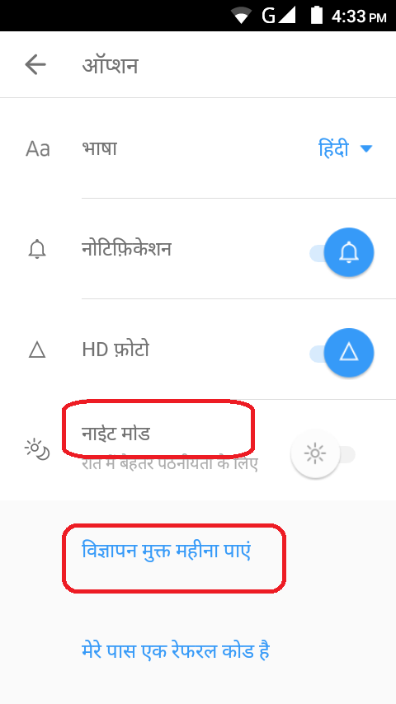

⦁ "Night mode"[hindi] text cut.

⦁ No "Search news", "Connect with Facebook" & "sync phone contacts" options are provided on options screen when user changes language to Hindi.

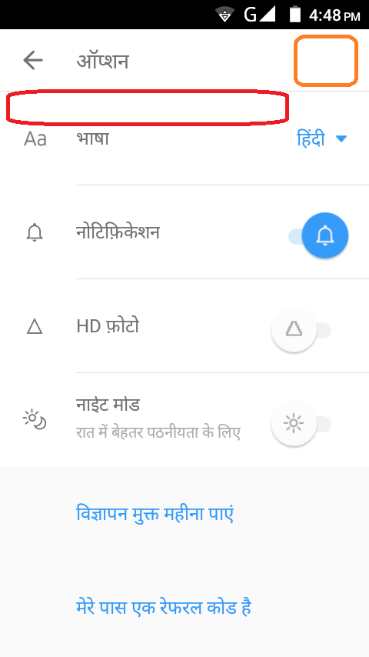

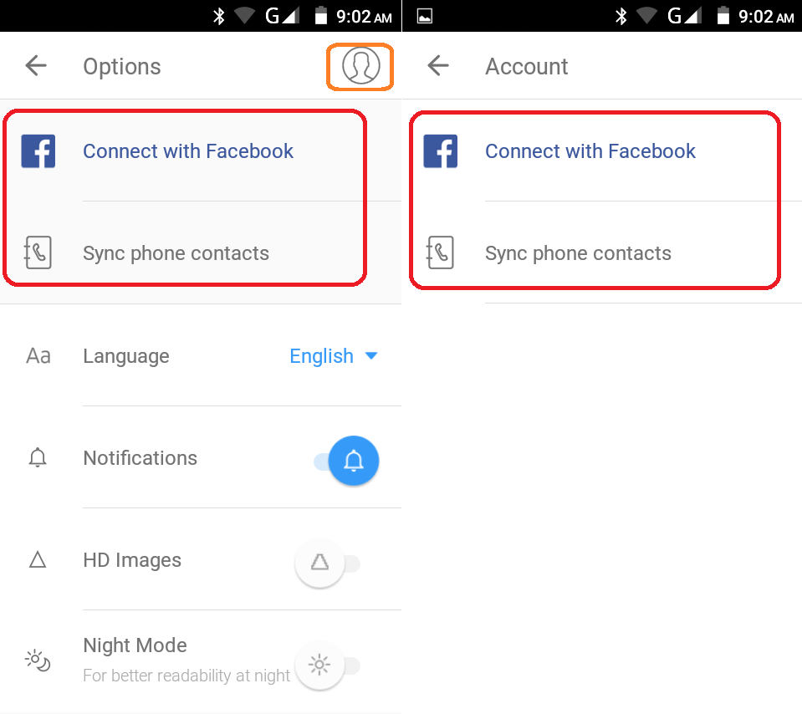

⦁ Same options "Connect with Facebook" and "Sync phone contacts" are provided in options as well as in account section. There is no meaning of providing separate accounts section with same options again. Accounts section should contain some additional options. Account section is not provided when hindi language is selected.

**ICICI Bank Web Site testing on phone browser :**

1) As user is accessing bank website on his phone, obviously the size of the phone screen is very small as compared with the normal desktop screen. So bank website should be responsive.

⦁ [Responsive Web Design is about using CSS and HTML to resize, hide, shrink, enlarge, or move the content to make it look good on any screen. A web page should look good, and be easy to use, regardless of the device] so that all the elements which are shown on normal desktop site can be shown to user on small screen.

2) Website should be loaded without losing any contents[Images, data, links etc.].

3) Web element should not overlap on any other element. Alignment of the elements should be proper.

4) On mobile device, menus of actual desktop website should be shown in single "Menu" tab and

submenus should be converted to accordion.[Recommended].

5) On phone, website should be scrolled vertically not horizontally. Horizontal scroll should be off.

6) Response time of the website should be less.

7) As user is accessing bank site, it should have security features like data encryption where user's data will be encrypted and saved on the server or database.

8) Images should be loaded on the correct / desired places, and all other elements should be shown as per the desired theme[Color, font, font size] of the application.

9) Logo of the "ICICI" should be shown correctly. [With correct colors and font].

10) Look and feel [Alerts, pop-ups, alignment of web elements, colors, fonts]of the web page should be same if it is opened in another version of the same browser OR on different browser.

11) User should not be redirected to inner pages of application[by adding page name in url after "/"], without creating a session [i.e without login]. If user try to do the same[adding page name in url], user should be redirected back to login page or main page.

12) Webpage should not respond to any sql statement written in url. Webpage/ site should not be vulnerable to attacks like sql injection.

13) Images, button images, link images should be loaded without blur/ pixelating effect.

14) If user zoom in the web page using two fingers [pinch zoom] then web page should be zoomed, without changing the alignments of web elements.

15) Design / functionality of the webpage /site should be simple and effective, so that any non technical or ordinary person can understand it properly. Website should be easy to use.

16) Load should be managed well, so that every person[User / Customer] can access the site without any issues.

**Suggestions & bugs :-**

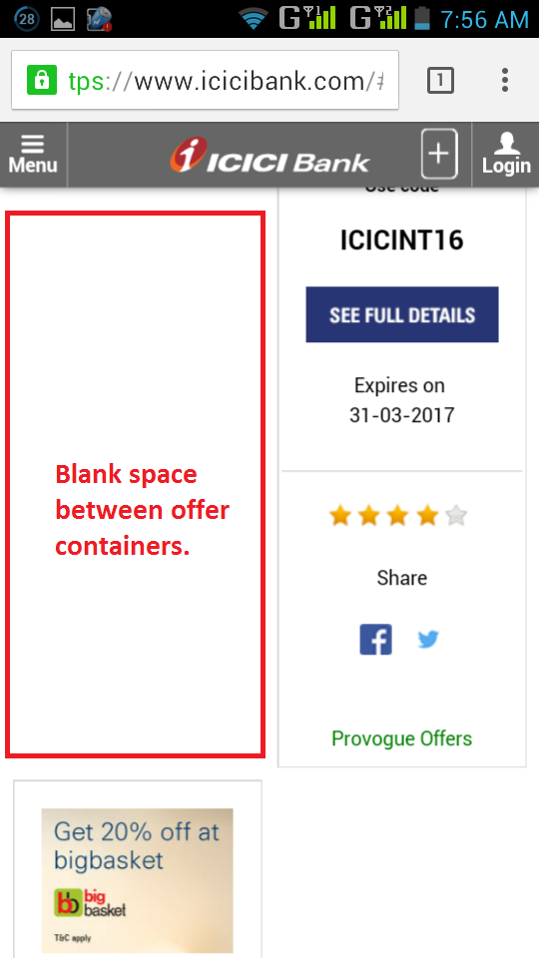

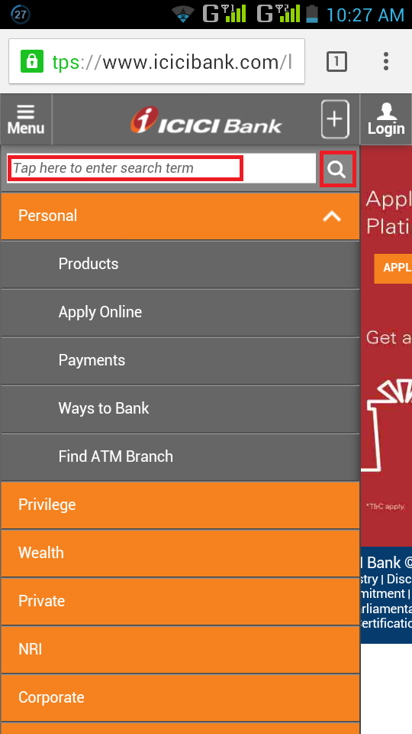

⦁ Without entering search term when tapped on "search", user is redirected to the search page with '0' results found message. Validation message should be shown to the user, when search text field is unchanged and tapped on search button.